

**VALOUR**

**RULE BOOK**

***STORYLINE OF VALOUR***

***VALOUR*** is an Island with and emerging reactor that would greatly increase in power and strength of a certain empire. This game depicts the war that takes place in control of the island. Their **objective** is **to conquer the most number of zones in the island where the powerful reactor will be proclaimed by the winner of the war**. There are four empires that are wedging war against one another. The game starts as each empire deploys their army troops from the shore of the island on each side of the cardinal direction (NORTH, SOUTH, EAST, and WEST). The war begins.

**RULES & REGULATION**

***General Rules:***

1. This game can be played by a total of 5 players where 4 players are in a team or against one another and another player as the Keeper. However, if there are only 3 players, then 2 player plays and the other is the Keeper. The role of a Keeper is essential part of the games thus there must always be player occupying the role.
2. To begin the game, each player sits according to their respective chosen colour area.
3. The game begins with either the younger player starts his turn first and moves in anti-clockwise from there or the players roll the dice and the highest number starts in the direction as mentioned.
4. This games objective is to be the top surviving player with the most number of zone under his control in the island.
5. The game is played for 2 hours.
6. Each player starts the game with 2 troops, a tank and a battleship card at their respective preparation zone.
7. The players to begin placing troops on their main base located near their preparation area, and on the following round the players will advance their troops in capturing new zone from the base.
8. Each player will be given a flowchart that points out what you’re supposed to do on your turn.
9. Once they have placed their troops on their sub-reactor, they begin by drawing a question card that will allow them to obtain more troops. Each card has its own troop amount specified depending on difficulty of the question. After reading the question, the players will have to answer the question to the keeper. The keeper will decide whether he/she has provided the correct answer. If he/she fails, his/her turn is over however if he/she succeeds, troops will be awarded by the keeper. Hence, he/she may begin planning their attack on an unoccupied zone or an occupied. If the player succeeds in capturing the zone he/she may draw an upgrade card that will be only applicable on his/her next turn. This marks the end of a players turn and the next player may begin his/her turn.
10. At the end of the 2 hour time frame, the person that holds the highest number of zones wins.

**PHASE 1: GETTING TROOPS**

1. **Drawing A Question Card**

Each question card has its specified number of troops allocated. Only by answering the question from the question card correctly will you able to receive troops. Partial answer is not accepted and will be treated as unable to answer.

1. **Placing Troops On Your Zone**

****Place your operational troops in any zone you control. You can put them all in the same zone or divide them as you wish.

1. **Play Upgrade Cards**

If you have any upgrade cards, you can play them now. Certain cards are required to be played in phase 1, most in phase 2 (attack) while the other will be during phase 3 (defend). Read the cards instruction carefully before playing to avoid your upgrade card to be wasted for incorrect usage. Used cards are sent to discard pile.

**PHASE 2: ATTACK**

* You can only attack an enemy zone that neighbours one of yours.
* Furthermore, you can only attack if you have 2 or more troops in the zone you are attacking from because at least one must be left behind to defend that zone.
* During an attack, the attacker and defender can play upgrade cards during attack. Each card tells you when to play it and how it affects the attack. During this point of the game is where the Keeper’s role is important, the keeper overseas the game and mediates the war when upgrade cards are used.
* If you have no robots on the game board, your army is destroyed and you are unable to answer the question in the following two rounds you are out of the game! Return your cards (if any) to the draw pile and reshuffle it.

**ARMY COMPOSITION**

Troops

* A land unit that can attack any other units even tanks except for Battleship.

Tanks = 3 troops

* ****A tank is a heavy weapons land unit that is equivalent to 3 troops and is exchangeable anytime during the game. The tank is the only unit that can attack the Battleship head on.

Battleship

* The Battleship is the only navy unit that is able to attack anywhere & anytime on the game board provided with if the player is able to pay the cost for the attack.
* The Battleship has two features where the attack is a photon missile which cost 8 troops to launch anywhere on the grid work where by 3 x 3 spaces of the stated coordinate all troops and tanks in the region are taken out in one go. **THE COORDINATES OF THE MISSILE LAUNCH HAS TO BE SPECIFIED TO THE KEEPER, AND THE KEEPER WILL BE INCHARGE OF REMOVING THE TROOPS FROM THAT SPACE.** The Battleship is able to defend itself however it has 3 lives, losing all its lives means that your battleship has sunken to the bottom of the sea and you’re unable to launch anymore missile attacks.
* There is a grid work of 14 x 15 which to help players launch your missile effectively. The horizontal grid is labelled with alphabets from A to T however the vertical grid is labelled with number 1 to 14.

**ROLLING DICE**

When a rolling the dices, your to roll the dice’s based on the number of troops you launch on the attack. However, if your number of troops is more than 3, you are still only eligible to 3 dices for the attack. The method of rolling the dice is up to you, each dice may be thrown separately or all three together, however only take the highest value on the dice based on your number of troops by your opponents.

**PHASE 3: DEFEND / CALLING FOR BACK-UP**

* Take as many troops as you want from one zone, remember to leave at least one troop to defend in every zone and move them to the connected zone, or the defending zone. Zones are connected if all the neighbouring zones between them have been conquered. There are upgrade cards for this phase.
* In case of a draw in attack, the defender wins unless an upgrade cards states otherwise.

**PHASE 4: DRAW A CARD**

* You can only draw a card once you have captured a zone. Keep the card hidden from the other players until you are ready to play it. Whenever, you have played an upgrade card, place it faceup on the discard pile.

**AT THE END OF PHASE 4, YOUR TURN IS OVER.**

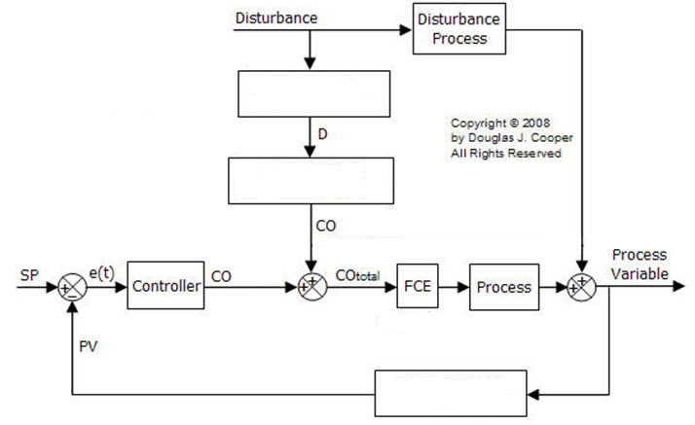**Question Card #7 (DIAGRAM)**



**VALOUR**

**ANSWER BOOKLET**

**ANSWERS FOR THE QUESTION**

**QUESTION 1**

Any of the 3 factors:

i. Wind Speed

ii. Atmospheric Stability

iii. Ground Conditions

iv. Height of release over ground level

v. Momentum & Buoyancy of initial material released



**QUESTION 2**

Any of the 2 types of reaction:

i. Homogeneous Reaction

ii. Heterogeneous Reaction

iii. Reversible Reaction

iv. Irreversible reaction

**QUESTION 3**

Answer:

{Rate of energy accumulation} = {Rate of energy in by convection} – {Rate of energy out by convection} + {net rate of heat addition to the system from the surroundings} +{net rate of work performed on the system by the surroundings}

**QUESTION 4**

**Any reactor with its advantage: (At least 2)**

|  |  |  |  |
| --- | --- | --- | --- |
| BATCH REACTOR | CSTR | PFR | PBR |
| Small scale operation | Continuous operation | Continuous operation | Continuous operation |
| May need high labour cost. | Steady state operation | Steady state operation | Involved catalyst |
| No outflow or inflow | Perfect Mixing  (no spatial variation) | Variation in axial direction only, no variation in radial direction |  |
| High conversion | Normally used for liquid phase reaction. |  |  |

**QUESTION 5**

Any 2 example of each process:

|  |  |
| --- | --- |
| **CONTINUOUS PROCESS** | **BATCH & SEMI-BATCH PROCESS** |
| Tubular Heat Exchange | Batch or semi-batch reactor |
| Continuous Stirred Tank Reactor (CSTR) | Batch Digester in a Pulp Mill |
| Thermal Cracking Furnace | Plasma Etcher in a Semi-conductor processing |
| Multicomponent Distillation Function | Kidney Dialysis Unit. |

**QUESTION 6**

Answer in this order: 2,5,4,1,3,6,7

**QUESTION 7**

Answer:

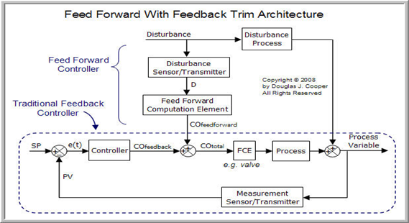

**QUESTION 8**

Answer:

a. The molecules need energy to distort or stretch their bonds so that the break them and form new bonds.

b. The steric and electron repulsion forces must be overcome as the reacting molecules come closer together.

**QUESTION 9**

Answer: Plug-flow Reactor – relatively easy to maintain, produces the highest conversion per reactor volume of any of the flow reactors.

**QUESTION 10**

Answer:

i. Wide aperture - large hole develops and substantial amount of material released in a short time.

(E.g. overpressure and explosion of a storage tank.)

ii. Limited aperture - material is released at a slow rate that upstream conditions are not immediately affected.

(E.g. Release from cracks, leaks, through holes etc.)

**QUESTION 11**

Answer: Acute exposure(air pollution) and chronic exposure

(Symptoms in human)

**QUESTION 12**

Answer: Plug Flow Reactor

Packed Bed Reactor

Batch Reactor

CSTR (Continuous Stirred Tank Reactor)

**QUESTION 13**

Answer: Feedback control measure the controlled variable.

Feed forward control measure the disturbance variable.

**QUESTION 14**

Answer: pbr4 Steady state

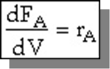**QUESTION 15**

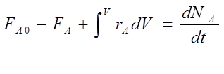Answer:



**QUESTION 16**

Answer: Homogeneous and Heterogeneous reaction ( liquid/gas phase )

**QUESTION 17**

Answer: Inhalation, Injection, Absorption, Ingestion

**QUESTION 18**

Answer: The dependent variable does not change with spatial location within the process.

**QUESTION 19**

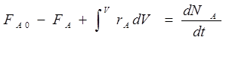Answer:

**QUESTION 20**

Answer: 

**QUESTION 21**

Answer:

1. Flow system is a continuous process, batch system is one-off production.
2. Flow system consumes low cost but batch system require higher cost to operate.
3. Easy to clean batch reactor but not flow reactor.
4. Batch reactor can be used for other production but flow system can only use for one reaction.

**QUESTION 22**

Answer: PID

**QUESTION 23**

Answer: Fail to control the level inside the reactor, causing the reactor to overflow/underflow. This will break down the reactor, and in worst scenario will cause accident and fatality.

**QUESTION 24**

Answer:

High pressure causes explosion if the column cannot withstand the pressure exerted, or causing the column to malfunction. Method to overcome: install the pressure detector, and the controls and transmitters.

**QUESTION 25**

Answer:

The volume change of the reaction above. Precaution: include the volume change factor in the designing equation of reactor. Install proper control instrumentation to prevent the volume change that causes the pressure change.

**QUESTION 26**

Answer:

i. Level control- overflow may occur and may disturb working experience and also cause fatality.

ii. Pressure control- Overpressure may cause explosion or leakage of toxicant.

iii. Temperature control- Overheating and may also cause explosion.

**QUESTION 27**

Answer: Inhalation-breathing smoking and Absorption-through skin

Continuous reactor-CSTR reactor

**QUESTION 28**

Answer:

The contamination of water with methyl isocyanate(MIC) that heated the MIC above its boiling point. Causing the pressure to increase and the gas release from pressure relief system.

Method:

i. Use a stainless steel pipeline system as it reduces the chance of corrosion that causes leakage.

ii. Always make sure that all the safety devices like vent gas scrubber, valve, and gas flare safety system are working properly.

iii. Installation of safety system like refrigeration system.

**QUESTION 29**

Answer:

a. Massive leakage of gas condensate on Piper Alpha, which was gnited causing an explosion which led to large oil fires. Safety valve was removed for maintenance, which causes pressurization and leakage.

b. Improvements to the "permit to work" management systems Relocation of some pipeline emergency shutdown valves Installation of sub sea pipeline isolation systems Mitigation of smoke hazards Improvements to evacuation and escape systems Initiation of Formal Safety Assessments.

**QUESTION 30**

Answer:

Dose amount of toxicant exposed(toluene) response curve- its effect corresponding to the amount of dose received. By knowing these relation, one is able to be more aware and careful on the dose and effect of toluene to their body

**QUESTION 31**

Answer: Property of the agent describing its effect on biological organisms.

**QUESTION 32**

Answer:

a. Homogeneous reaction occurs in one single phase whereas heterogeneous reaction can occur in different phases.

b. Catalyst for homogeneous reaction is as the same as the phase present i.e. liquid with liquid and catalyst for heterogeneous reaction is of a different phase from the reactant i.e. solid catalyst in a liquid reactant.

**QUESTION 33**

Answer:

a. Theoretical model

b. Empirical Model

c. Semi Empirical Model

**QUESTION 34**

Answer:

a. Sensor 🡪 Skin / Any body parts

b. Transmitter 🡪 Neuron

c. Controller 🡪 Brain

d. Control Element 🡪Action (Depends on situation)

**QUESTION 35**

Answer: Input + Output + Accumulation → Accumulation

**QUESTION 36**

Answer: An explosion and the resulting oil and gas fires destroyed it.

**QUESTION 37**

Answer:

A chemical reaction in which one or more of the chemical species react directly to form products in a single reaction step and with a single transition state.

**QUESTION 38**

Answer: $-r_{A}=kC_{A}C_{B}^{2}$

**QUESTION 39**

Answer:

a. A gas is a substance above its critical temperature but below its critical pressure, while a vapour is a substance above its boiling point temperature.

b. A vapour at room temperature can revert back to its liquid form while gas at room temperature might not able to liquefy.

c. A vapour natural condition at room temperature is liquid or solid while a gas natural condition at room temperature is a gas.

**QUESTION 40**

Answer: Negative sign for reaction A shows that A is being consumed in the reaction while positive sign for reaction of C shows that it is being generated.

**QUESTION 41**

Answer in this order : 4-2-3-1

**QUESTION 42**

Answer: Always use alloy or stainless steel pipeline system as it reduce the chance of corrosion that causes leakage

**QUESTION 43**

Answer: Dose and Response curve

**QUESTION 44**

Answer: Elementary reaction

**QUESTION 45**

Answer: Pressure Control

**QUESTION 46**

Answer: Plug flow reactors have a high volumetric unit conversion, run for long periods of time without maintenance, and the heat transfer rate can be optimized.

**QUESTION 47**

Answer: Interacting Process

**QUESTION 48**

Answer: Fluid flow of the pipe and chemical analysis / transport of solid material.